PorTel Beacon User Manual

Author: Nicholas Belsten; nbelsten@mit.edu

First Created: 8/11/2022

Current Revision: V1.0

Revision Date: 8/28/2022

# Introduction

Portel is the ground station designed for use with the MIT CLICK spacecraft. PorTel provides a beacon laser which the spacecraft then uses as a pointing reference. The integration and operation of this beacon laser is the subject of this manual.

The PorTel ground station beacon laser is based around the EM337 manufactured by Goose and Housego. This laser is in a butterfly package with a fiber coupled optical output. Key electrical interfaces to this laser diode include a thermoelectric cooler (TEC) driver, the laser current driver, and an optical power meter readout. The “Beacon Board” is the primary electronic device which integrates the laser diode package into a more usable system.

## Laser Safety

The beacon laser produces up to 5 Watts of optical output at 975 nm; this is a class IV laser capable of burning and blinding people by direct and indirect radiation. This user manual is not intended to cover laser safety. The user should follow laser safety protocols as specified by their environmental health and safety department or equivalent.

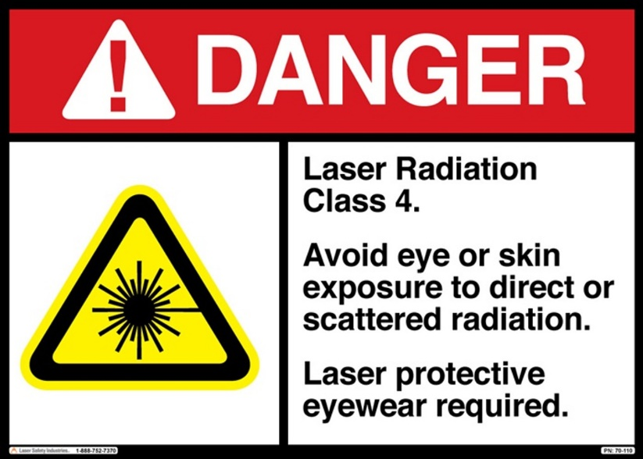

# Operational Interface

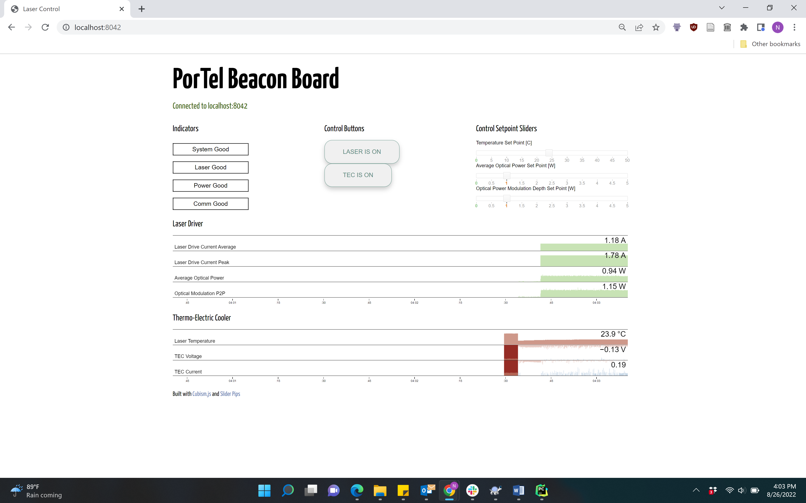

Figure 1: Screenshot of Operational Interface

The interface is accessed by internet browser as discussed in a later section.

Below the title, a message indicates whether the browser is connected to the server (localhost:8042 in this case).

## Indicators

The *Indicators* will turn red and include an error message if the server has detected off-nominal operation. The three bottom indicators contain specific error messages related to the laser diode, the power supplies[1], and the communication between the served computer and the laser microcontroller. The “System good” indicator summarizes the state the lower three indicators.

## Control Buttons

The control buttons can be clicked to toggle the operation of the laser optical power the TEC. The TEC and laser optical power can be controlled separately.

## Control Setpoint Sliders

These sliders set analog values controlling the laser operation. The temperature set point controls the TEC operation. The average optical power controls the laser average optical power, and the optical power modulation depth controls the peak-to-peak laser optical modulation depth. For example, 2.5 Watts average power and 5 Watts optical modulation depth would produce a sine wave (approximately) ranging from 0 to 5 Watts optical power.

## Laser Driver Graphs

|  |  |
| --- | --- |
| Laser Driver Current Average | The average current expected to be flowing through the laser diode based on the *electrical* laser current feedback. |
| Laser Driver Current Peak | The peak current expected to be flowing through the laser diode based on the *electrical* laser current feedback. |
| Average Optical Power | The average optical power from the laser diode as measured by the *optical* sensing photodiode internal to the laser package. |
| Optical Modulation P2P | The average optical power peak-to-peak modulation from the laser diode as measured by the *optical* sensing photodiode internal to the laser package. |

## Thermo-Electric Cooler Graphs

Measured laser temperature, TEC current, and voltage, all as directly measured by the laser board microcontroller.

# Integration and Setup

The Beacon Board has been shipped mounted on a heat spreader and attached to a long fiber optic cable with an APC connector.

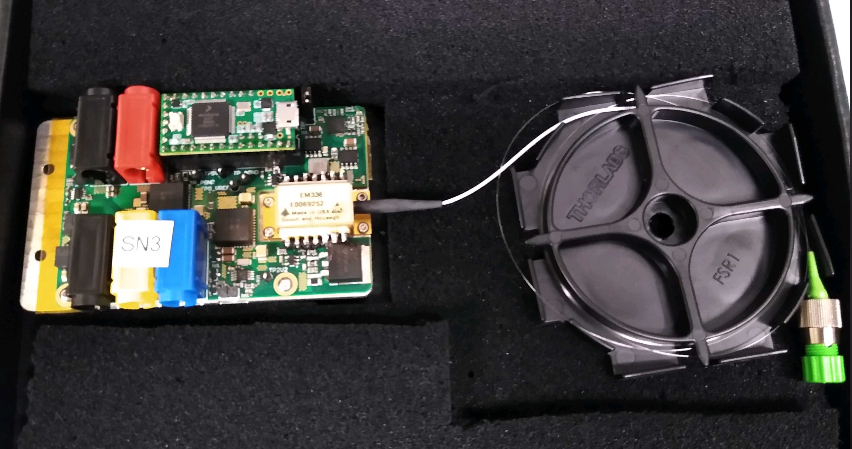

## Power

The board should be powered by a 12 Volt power supply capable of providing at least 4 Amps.

The 12 Volt positive and negative should be connected to the red and black banana jacks which are next too each other. The set of three banana jacks (black, yellow, blue) are used to optionally provide power to other systems and do not need to be used.

The fiber should be unwound and the APC connector connected to a collimator. Be careful to avoid pulling on the fiber, or bending the fiber with less than 3 cm radius.

## Heat Sinking

The aluminum heat spreader conducts heat away from the beacon laser diode and the rest of the PorTel Beacon Board. The heat spreader alone provides enough thermal mass to operate the laser at full power for ~30 seconds. Eventually, the entire assembly will become to hot for the TEC to keep the laser at operational temperature. For longer operation the heat spreader should be connected to a large thermal mass (such as thick optical plate or large finned heat sink). The total thermal dissipation of the board during normal operation is about 30 Watts.

## Optical

The APC connector is intended to be connected to a collimator. The fiber should be cleaned after any exposure to contaminants and prior to any operation at significant power (more than 0.1 Watts). Bends in the optical fiber tighter than about 4 cm bend radius may cause the fiber to begin to leak power. At tight bend radiuses of <2 cm a large fraction of the optical power will be leaked from the fiber. Note that light may also leak from the fiber splice even if unbent. This is usually not a significant fraction of the total power but may be sufficient to present a safety hazard.

## Interlock

The interlock is used to enforce safer operation. The interlock interface is two header pins on the board next to the blue banana jack. One pin is connected to the 12V line through a large resistance resistor. When the two pins are *connected together* (notionally by a safety switch) the laser is *operational.* If the pins are not connected together, the laser is not operational. The safety switch should be connected so that the switch enforces the laser being non-operational unless extra steps are taken. Note that if the wires to the interlock become accidentally disconnected, the laser becomes non-operational (as the pins will not be connected together).

## Data + Control

The Raspberry Pi must be connected to the microcontroller on the beacon board via a micro-USB cable. This cable must have data capability (not just power). The Raspberry Pi must also be powered on separately by a USB-C power supply.

# Software Operation

The provided Raspberry Pi has operational software installed. This can be accessed by navigating to the PorTel directory (a git clone of <https://github.com/MIT-STARLab/PorTel-Beacon-sw>), then to Python_GUI -> PorTel_Pi_Code. Run python3 main.py to start the server.

If the USB cord is connected, the server will connect to the beacon board microcontroller over the USB cable.

Once the server is running, the server GUI can be accessed by browser using port 8042. To access the GUI on the Raspberry Pi navigate to localhost:8042. The GUI can also be accessed from another computer through a network by using the IP address of the Raspberry Pi.

As necessary, the Python controller software can be updated with a git pull inside the PorTel directory.

## Constants / Parameters

Some of the software operation can be changed via parameter in the constants.py file. Here we highlight two parameters.

First, the optical power readout has been calibrated using an independent optical power meter for each serial number of the beacon board. This constant is added as a comment for each serial number in the software. You should set the POWER_CALIBRATION_MULTIPLIER to the value for your serial number.

Secondly, the optical power setpoint can be operated in either open loop or closed loop modes. If   
USE_PID = False then the laser power will be set open-loop, this appears to create optical power in a manner stable to within ~10%. If USE_PID = True, then PID control loops will attempt to correct errors in the optical power average and modulation depth. Note that if the laser or optical power feedback is not operating correctly, this may make the current through the laser increase to the maximum possible. This should not damage the laser if the system is properly thermally bonded, but can create dangerous levels of optical power output when the user is expecting a smaller amount of power.

# Checkout Testing / Operation Example

1. Setup the Raspberry Pi
   1. Connect the Pi to power
   2. Connect the Pi to the microcontroller by USB
   3. Turn on the raspberry Pi
   4. Start the main server
2. Setup the beacon board
   1. Connect the interlock to the interlock switch
   2. Connect the APC connector to the collimator or optical sink of choice
   3. Connect the red and black banana jacks to the 12V power source
   4. FOLLOW APPROPRAITE SAFETY PROCEDURE FOR YOUR OPERATION
   5. Turn on the power supply
3. In the GUI
   1. Set the TEC setpoint to a reasonable operational temperature (e.x. 30 C)
   2. Turn on the TEC via button (note the TEC PID controller may take several seconds to stabilize when initially turned on)
   3. Turn the laser on via button
   4. Turn the optical power on to 1 Watt
      1. Observe the readout optical power to ensure proper operation
   5. Turn the laser off with the button
   6. Turn the TEC off with the button

# API

Some programmatic function has been wrapped in simpler functions contained in Controller_API.py.

An “example_script” function shows the intended operation.

As of V1.0 of this manual, the API has not been thoroughly tested. Further development is expected, please work with Nick ([nbelsten@mit.edu](mailto:nbelsten@mit.edu)) to identify bugs and new desired features.

# Hardware Summary

The PorTel beacon hardware is comprised of the PorTel Beacon Board and the Raspberry Pi interface computer. The Beacon Board is discussed in detail here.

### Block Diagram

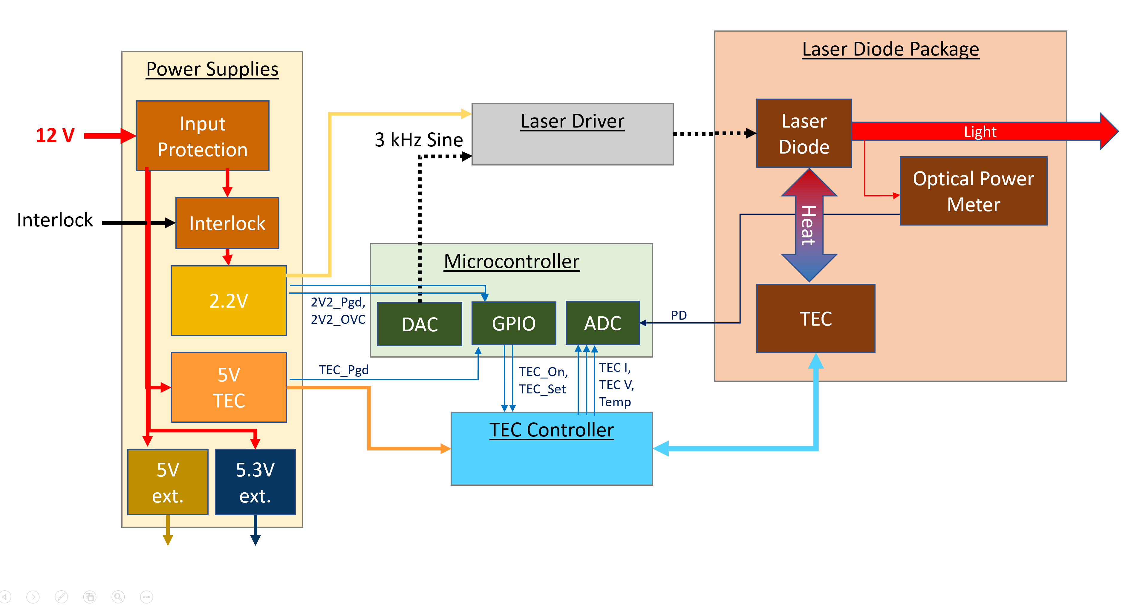

### Power Supplies

The power supplies are all derived from 12 V. The 12 volt input has a reverse polarity overcurrent protection electronic fuse. The electronic fuse is set for a nominal trip current of 8.8 Amps. A 5 volt power module provides power to the TEC. The 2.2 Volt power module is used to drive the laser diode. This power module is interlocked with an external switch. If the external switch does not provide connection between the two interlock conductors than the laser diode will never turn on. This provides additional laser safety when the external switch is properly configured to ensure proper access protocols.

There are additional 5V and 5.3V power connections for other PorTel equipment besides the Beacon Board system.

### Laser Drive

The laser driver produces a fixed current through the laser diode that is proportional to the applied voltage derived from an ADC. This is achieved by an operational amplifier driving a large power MOSFET operated in the linear mode. The current through the laser diode is used as a source of negative feedback for the operational amplifier. The laser driver nominal bandwidth is 60 kHz.

### TEC Control

TEC control is provided by a dedicated special purpose integrated circuit. While the PCB hardware can theoretically support either hardware or software PID control of the TEC, poor performance has been consistently observed from the hardware PID implementation. The P7 jumper indicated below should be *inserted* at all times to bypass the hardware PID and allow for software PID control.

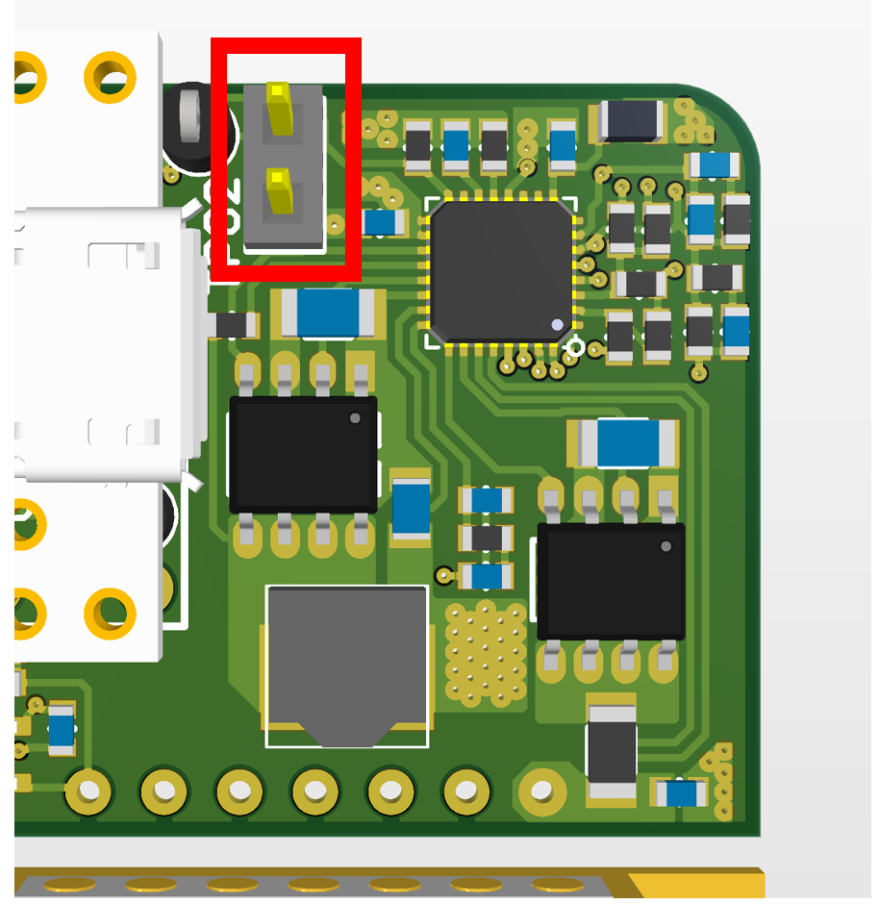

## Digital Interface

The digital interface between the computer board and the PorTel beacon board is provided by a Teensy 3.2 microcontroller.

## Interface Computer / Raspberry Pi

The Raspberry Pi connects to the PorTel microcontroller via USB cable. The Raspberry Pi runs the higher-level control software. The Raspberry Pi exchanges an outgoing and incoming packet with the microcontroller at approximately 50 Hz, though this is not implemented as a hard-real-time requirement.

1. One common error indicated is 2V2 power error. This is usually caused by the interlock removing power from the laser diode for safety. To operate the laser, check that the interlock is properly wired and that the switch is in the activated position.